# BEYOND SYLLABUS

## Aim: Create a simple program using RMI.

### **AddI.java Code**

import java.rmi.Remote;  
public interface AddI extends Remote  
{ public int add(int x,int y) throws Exception; }

**AddC.java Code**  
import java.rmi.*;  
import java.rmi.server.*;  
public class AddC extends UnicastRemoteObject implements AddI  
{ AddC() throws Exception

{ super(); }  
public int add(int x,int y)  
{ return x+y; }

}

**Server.java Code**  
import java.rmi.*;  
public class Server  
{ public static void main(String args[]) throws Exception

{ AddI obj = new AddC();

Naming.rebind("Adder",obj);

System.out.println("Server Started");

}

}

### **Client.java Code**

import java.rmi.*;  
import java.util.Scanner;  
public class Client  
{ public static void main(String args[]) throws Exception

{ AddI obj=(AddI)Naming.lookup("Adder");

Scanner scan=new Scanner(System.in);

System.out.println("Enter 2 numbers to do addition:");

int a=scan.nextInt();

int b=scan.nextInt();

int sum=obj.add(a,b);

System.out.println("Addition :\t" + sum);

}

}  
  
Output:

#### Commands

[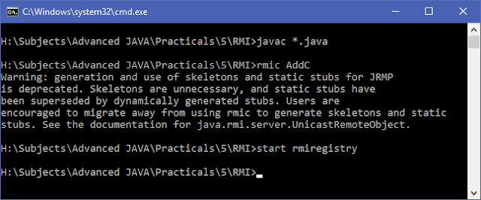](https://4.bp.blogspot.com/-LbR7Gi4yyZo/WOZH-fscFRI/AAAAAAAADxY/s-UmT9Y8EXg0zveoYNFGs7KFw7JzQOB2wCLcB/s1600/Commands.png)

#### Server

[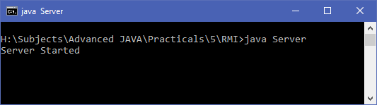](https://4.bp.blogspot.com/-e1pqAuNHwUk/WOZIJsrnBaI/AAAAAAAADxc/xbDMBZHI32gG_RYUvkCkfM4k67EXorRBwCLcB/s1600/Server.png)